The Toronto-Calcutta Foundation
Registered charitable business # 888243391 RR0001



Enclosed please find my gift of $__________

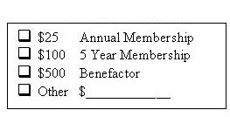 | Name:______________________________
 | Address:____________________________
 | ___________________________________
 | ___________________________________
 | Telephone:__________________________
 | Name on Tax Receipt:_________________

Thank you for your support!
Official tax receipts will be issued for all donations over $10.00

Please make cheques payable to THE TORONTO-CALCUTTA FOUNDATION
and send to:

2 Leland Avenue, Toronto, ON, M8Z 2X5

